**YASH SARANG**

**D6AD**

**47**

**DLCOA / Experiment 10**

------------------------------------------------------------------------------------------------------------------------

AIM: To write a C program to implement Booths algorithm using

C/C++.

------------------------------------------------------------------------------------------------------------------------

SOFTWARE: Turbo C IDE

------------------------------------------------------------------------------------------------------------------------

THEORY:

Booth’s multiplication algorithm is a multiplication algorithm that multiplies two signed binary numbers in two’s complement notation.

The algorithm was invented by Andrew Donald Booth in 1950 while doing research on crystallography at Birkbeck College in Bloomsbury, London. Booth used desk calculators that were faster at shifting than adding and created the algorithm to increase their speed.

Booth’s algorithm is of interest in the study of computer architecture.

The Booth’s algorithm generates a 2n- bit product and treats both positive and negative 2’s- complement n- bit operands uniformly.

Booth's algorithm has two attractive features. First, it handles both positive and negative multipliers uniformly. Secondly, it achieves some efficiency in the number of additions required when the multiplier has few large blocks of 1s.

The speed gained by skipping over 1s depends on the data.

------------------------------------------------------------------------------------------------------------------------

Algorithm:-

1. START

2. Initialize A=0 and

3. If Q, = 01 add and right shift

= 10 subtract and right shift

= 00 or 11 right shift

4. Decrement the counter untill operation is performed on every bit

5. STOP

------------------------------------------------------------------------------------------------------------------------

Flowchart:-

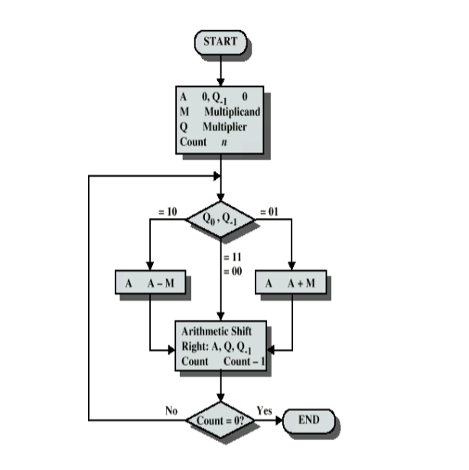

------------------------------------------------------------------------------------------------------------------------

Program:-

*#include <stdio.h>*

*#include <math.h>*

*int a = 0,b = 0, c = 0, a1 = 0, b1 = 0, com[5] = { 1, 0, 0, 0, 0};*

*int anum[5] = {0}, anumcp[5] = {0}, bnum[5] = {0};*

*int acomp[5] = {0}, bcomp[5] = {0}, pro[5] = {0}, res[5] = {0};*

*void binary(){*

*a1 = fabs(a);*

*b1 = fabs(b);*

*int r, r2, i, temp;*

*for (i = 0; i < 5; i++){*

*r = a1 % 2;*

*a1 = a1 / 2;*

*r2 = b1 % 2;*

*b1 = b1 / 2;*

*anum[i] = r;*

*anumcp[i] = r;*

*bnum[i] = r2;*

*if(r2 == 0){*

*bcomp[i] = 1;*

*}*

*if(r == 0){*

*acomp[i] =1;*

*}*

*}*

*//part for two's complementing*

*c = 0;*

*for ( i = 0; i < 5; i++){*

*res[i] = com[i]+ bcomp[i] + c;*

*if(res[i] >= 2){*

*c = 1;*

*}*

*else*

*c = 0;*

*res[i] = res[i] % 2;*

*}*

*for (i = 4; i >= 0; i--){*

*bcomp[i] = res[i];*

*}*

*//in case of negative inputs*

*if (a < 0){*

*c = 0;*

*for (i = 4; i >= 0; i--){*

*res[i] = 0;*

*}*

*for ( i = 0; i < 5; i++){*

*res[i] = com[i] + acomp[i] + c;*

*if (res[i] >= 2){*

*c = 1;*

*}*

*else*

*c = 0;*

*res[i] = res[i]%2;*

*}*

*for (i = 4; i >= 0; i--){*

*anum[i] = res[i];*

*anumcp[i] = res[i];*

*}*

*}*

*if(b < 0){*

*for (i = 0; i < 5; i++){*

*temp = bnum[i];*

*bnum[i] = bcomp[i];*

*bcomp[i] = temp;*

*}*

*}*

*}*

*void add(int num[]){*

*int i;*

*c = 0;*

*for ( i = 0; i < 5; i++){*

*res[i] = pro[i] + num[i] + c;*

*if (res[i] >= 2){*

*c = 1;*

*}*

*else{*

*c = 0;*

*}*

*res[i] = res[i]%2;*

*}*

*for (i = 4; i >= 0; i--){*

*pro[i] = res[i];*

*printf("%d",pro[i]);*

*}*

*printf(":");*

*for (i = 4; i >= 0; i--){*

*printf("%d", anumcp[i]);*

*}*

*}*

*void arshift(){//for arithmetic shift right*

*int temp = pro[4], temp2 = pro[0], i;*

*for (i = 1; i < 5 ; i++){//shift the MSB of product*

*pro[i-1] = pro[i];*

*}*

*pro[4] = temp;*

*for (i = 1; i < 5 ; i++){//shift the LSB of product*

*anumcp[i-1] = anumcp[i];*

*}*

*anumcp[4] = temp2;*

*printf("\nAR-SHIFT: ");//display together*

*for (i = 4; i >= 0; i--){*

*printf("%d",pro[i]);*

*}*

*printf(":");*

*for(i = 4; i >= 0; i--){*

*printf("%d", anumcp[i]);*

*}*

*}*

*void main(){*

*int i, q = 0;*

*printf("\t\tBOOTH'S MULTIPLICATION ALGORITHM");*

*printf("\nEnter two numbers to multiply: ");*

*printf("\nBoth must be less than 16");*

*//simulating for two numbers each below 16*

*do{*

*printf("\nEnter A: ");*

*scanf("%d",&a);*

*printf("Enter B: ");*

*scanf("%d", &b);*

*}while(a >=16 || b >=16);*

*printf("\nExpected product = %d", a * b);*

*binary();*

*printf("\n\nBinary Equivalents are: ");*

*printf("\nA = ");*

*for (i = 4; i >= 0; i--){*

*printf("%d", anum[i]);*

*}*

*printf("\nB = ");*

*for (i = 4; i >= 0; i--){*

*printf("%d", bnum[i]);*

*}*

*printf("\nB'+ 1 = ");*

*for (i = 4; i >= 0; i--){*

*printf("%d", bcomp[i]);*

*}*

*printf("\n\n");*

*for (i = 0;i < 5; i++){*

*if (anum[i] == q){//just shift for 00 or 11*

*printf("\n-->");*

*arshift();*

*q = anum[i];*

*}*

*else if(anum[i] == 1 && q == 0){//subtract and shift for 10*

*printf("\n-->");*

*printf("\nSUB B: ");*

*add(bcomp);//add two's complement to implement subtraction*

*arshift();*

*q = anum[i];*

*}*

*else{//add ans shift for 01*

*printf("\n-->");*

*printf("\nADD B: ");*

*add(bnum);*

*arshift();*

*q = anum[i];*

*}*

*}*

*printf("\nProduct is = ");*

*for (i = 4; i >= 0; i--){*

*printf("%d", pro[i]);*

*}*

*for (i = 4; i >= 0; i--){*

*printf("%d", anumcp[i]);*

*}*

*}*

------------------------------------------------------------------------------------------------------------------------

Output:-



